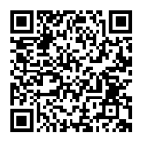
ITGB6(12X16)Rabbit Monoclonal Antibody
产品详情

产品货号 | 产品名称 | 储存条件 | 保质期
IM68763 | ITGB6(12X16)Rabbit Monoclonal Antibody | -20℃ | 1年
产品概述：
产品货号 | IM68763
产品名称 | ITGB6(12X16)Rabbit Monoclonal Antibody
类别 | 抗体产品
基因名称 | ITGB6
蛋白名称 | Integrin beta-6
推荐应用 | WB,IHC-P,IF-P,IF-F,IF-ICC,IP,ELISA
反应种属 | Human,Mouse,Rat
存储缓冲液 | PBS, 50% glycerol,0.05% Proclin 300,0.05%BSA
Human Gene ID | 3694
Human  Swissprot No. | P18564
Mouse  Swissprot No. | Q9Z0T9
Rat  Swissprot No. | Q6AYF4
稀释度 | IHC-P 1:2000-1:10000,WB 1:1000-1:5000,IF-P/IF-F/IF-ICC 1:200- 1:1000,ELISA 1:5000 1:20000,IP 1:50-1:200

参考分子量 | 86kDa
预测分子量 | 86kDa
运输及保存条件 | -20℃/1 year(Do not lower than -25℃)
宿主 | Rabbit
同种型 | Monoclonal,rabbit,IgG,Kappa
背景介绍 | This gene encodes a protein that is a member of the integrin superfamily.Members of this family are adhesion receptors that function in signaling from the extracellular matrix to the cell. Integrins are heterodimeric integral membrane proteins composed of an alpha chain and a beta chain.The encoded protein forms a dimer with an alpha v chain and this heterodimer can bind to ligands like fibronectin and transforming growth factor beta 1.Alternate splicing results in multiple transcript variants.[provided by RefSeq,Sep 2013].
信号通路 | Focal adhesion;ECM-receptor interaction;Regulates Actin and Cytoskeleton;Hypertrophic cardiomyopathy(HCM);Arrhythmogenic right ventricular cardiomyopathy(ARVC);Dilated cardiomyopathy.
功能 | Function:Integrin alpha-V/beta-6 is a receptor for fibronectin and cytotactin.It recognizes the sequence R-G-D in its ligands. similarity:Belongs to the integrin beta chain family.similarity: Contains 1 VWFA domain.subunit:Heterodimer of an alpha and a beta subunit.Beta-6 associates with alpha-V.Interacts with FLNB. Alpha-V/beta-6 binds to foot-and-mouth disease virus(FMDV)VP1 protein,coxsackievirus A9,coxsackievirus B1 capsid proteins and acts as a receptor for these viruses.

纯化 | Protein A
Clonality | Monoclonal
注意事项：
1.我司生产的生化试剂如无特殊标注，基本为非无菌包装，若用于细胞实验，请提前做好预处理。需低温保存的产品，一旦配成溶液，请分装保存，避免反复冻融造成的产品失效。
2.本产品仅限于专业人员的科学研究用，不得用于临床诊断或治疗，不得用于食品或药品，不得存放于普通住宅内。
3.为了您的安全和健康，请穿实验服并戴一次性手套操作。
4.实验结果受多种因素影响，相关处理仅限于产品本身，不涉及其他赔偿。

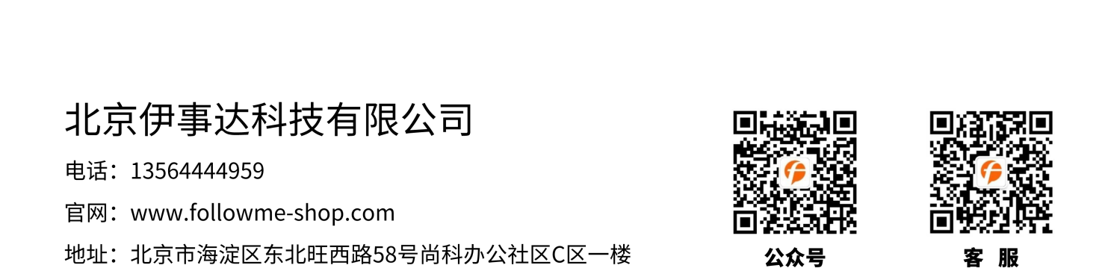
免责声明: 所有产品仅用作科学研究，不得用于其他用途！本公司将不为任何不正常使用此产品时所发生的意外负责。

