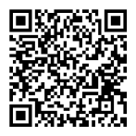
Phospholamban(Phospho S16)(3B11)
产品详情

Rabbit Monoclonal Antibody
产品货号 | 产品名称 | 储存条件 | 保质期
IM37157 | Phospholamban(Phospho S16)(3B11)Rabbit Monoclonal Antibody | -20℃ | 1年
产品概述：
产品货号 | IM37157
别名 | Cardiac phospholamban;CMD1P;CMH18;PLB;Pln
产品名称 | Phospholamban(Phospho S16)(3B11)Rabbit Monoclonal Antibody
纯度 | Affinity-chromatography
类别 | 抗体产品
基因名称 | PLN
蛋白名称 | PLB
推荐应用 | WB
反应种属 | Human,Mouse
存储缓冲液 | Rabbit IgG in phosphate buffered saline,pH 7.4,150mM NaCl,0.02% New type preservative N and 50% glycerol.Store at +4℃ short term. Store at -20℃ long term.Avoid freeze/thaw cycle.
Human Gene ID | 5350
Human  Swissprot No. | P26678

稀释度 | WB 1:1000-1:2000
参考分子量 | 11kDa
预测分子量 | 6kDa
运输及保存条件 | Biological ice bag transportation.Store at -20℃ for at least 12 months(Do not lower than 25℃).Avoid freeze/thaw cycles.
宿主 | Rabbit
同种型 | IgG
注意事项 | Phospho-Phospholamban(S16)Antibody is for research use only and not for use in diagnostic or therapeutic procedures.
组织表达 | Heart muscle(at protein level).
细胞定位 | Endoplasmic reticulum membrane;Single-pass membrane protein. Sarcoplasmic reticulum membrane;Single-pass membrane protein. Mitochondrion membrane{ECO:0000250|UniProtKB:A4IFH6};Single-pass membrane protein.Membrane{ECO:0000250|UniProtKB:P61014}; Single-pass membrane protein.Note=Colocalizes with HAX1 at the endoplasmic reticulum(PubMed:17241641).Colocalizes with DMPK a the sarcoplasmic reticulum(PubMed:15598648).
功能 | Reversibly inhibits the activity of ATP2A2 in cardiac sarcoplasmic reticulum by decreasing the apparent affinity of the ATPase for Ca(2+)(PubMed:28890335).Modulates the contractility of the heart muscle in response to physiological stimuli via its effects on ATP2A2.Modulates calcium re uptake during muscle relaxation and plays an important role in calcium homeostasis in the heart muscle. The degree of ATP2A2 inhibition depends on the oligomeric state of PLN.ATP2A2 inhibition is alleviated by PLN phosphorylation.

Clonality | Monoclonal
注意事项：
1.我司生产的生化试剂如无特殊标注，基本为非无菌包装，若用于细胞实验，请提前做好预处理。需低温保存的产品，一旦配成溶液，请分装保存，避免反复冻融造成的产品失效。
2.本产品仅限于专业人员的科学研究用，不得用于临床诊断或治疗，不得用于食品或药品，不得存放于普通住宅内。
3.为了您的安全和健康，请穿实验服并戴一次性手套操作。
4.实验结果受多种因素影响，相关处理仅限于产品本身，不涉及其他赔偿。

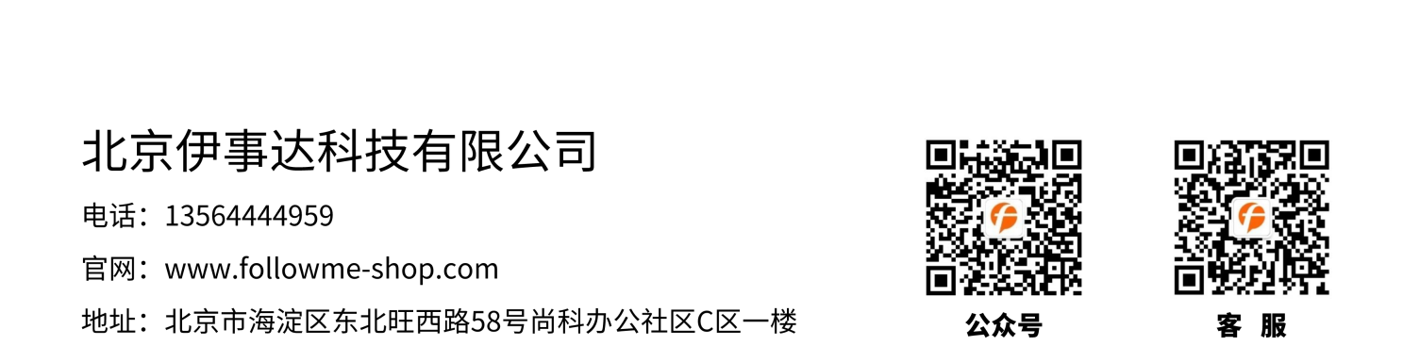
免责声明: 所有产品仅用作科学研究，不得用于其他用途！本公司将不为任何不正常使用此产品时所发生的意外负责。

